Sukkah 6b – Rashi on מַעֲמִידוֹ כְּנֶגֶד הַיּוֹצֵא
An example of where the manuscript evidence seems to be incorrect.

תָּנוּ רַבָּנַן: שְׁתַּיִם כְּהִלְכָתָן, וּשְׁלִישִׁית אֲפִילּוּ טֶפַח......
It was taught. (In order to construct a Kosher Sukkah), two of the walls must be walls in the standard sense, (sealing the entire length and height of the Sukkah,) and the third wall may be even one Tefach.
וְאוֹתוֹ טֶפַח הֵיכָן מַעֲמִידוֹ? אָמַר רַב: מַעֲמִידוֹ כְּנֶגֶד הַיּוֹצֵא.
The Gemara asks: According to the opinion that a Sukkah can be built with two full-fledged walls and a third that is one Tefach, where does one position that third wall that measures one Tefach? Rav said: He positions it at the end of one of the standing walls opposite the wall that emerges from the other end of that wall.

Rashi
כנגד היוצא - מקום שהמחיצה כלה באיזה שירצה אם השתים מזרחית צפונית יעשה הטפח בסוף הצפונית במקצועו לצד מערב או במזרחית לצד דרום:
The difficult expression here is כנגד היוצא and Rashi “illustrates” in words what this means. Although Rashi does not include the word “Kazeh”, it seems logical that there would be a diagram here to illustrate the two cases.
In fact, there are two diagrams in Rashi in the Vilna Shas. The first one illustrates where one complete wall is on the east side and one complete wall is on the north side, and the “wall” which is only a Tefach emerges at the north side. The second illustration is where there are the same two walls, (one on the east and one on the north) but the “wall” which is only a Tefach emerges at the southern side
East East
West West

Vilna Shas – Masechet Sukkah -First edition 1882
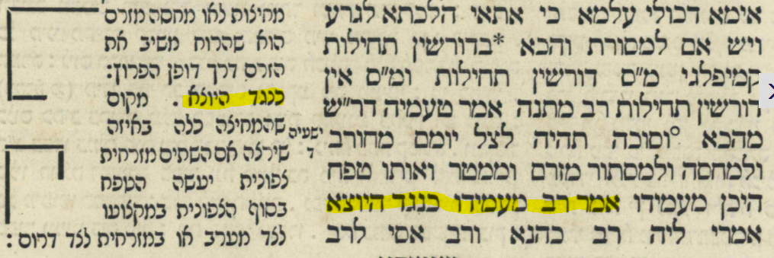

The Oz Vehadar Friedman edition “upgrades” the illustration in the Vilna Shas as follows. The first diagram parallels the first part of Rashi and the second diagram parallels the second part of Rashi. Notice that the words Mizrach, Tzafon, etc. are indicated. Oz Vehadar also shortened the third “wall” to show that it is only a Tefach.
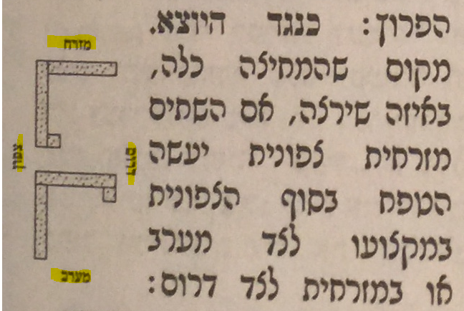

What is the source for the diagrams in Rashi?
There is one manuscript of Rashi on Masechet Sukkah which has this diagram. It is identified as JTS 6648. It includes the words כנגד היוצא טפח so it clearly references this comment of Rashi. Unfortunately, the illustration does not match the words of Rashi.
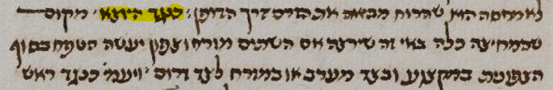
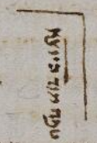
The best source for the diagrams is the D’fus Rishon of Masechet Sukkah printed in Pesaro, Italy by the Soncino family circa 1516. Although printed more than 350 years before the Vilna Shas, it actually gives a clearer picture of Rashi’s words by identifying Mizrach, Tzafon and Darom. It also specifies that the third “wall” is only a Tefach.
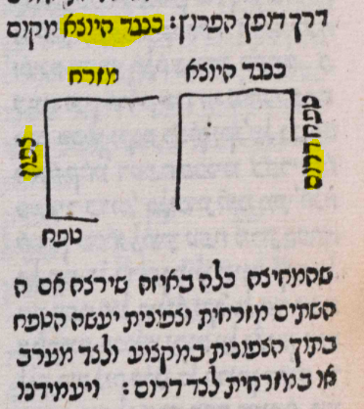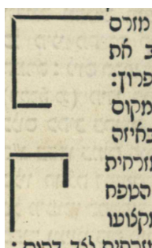
Pesaro 1516 Vilna 1882
The Bomberg edition of Masechet Sukkah printed in 1521 patterned itself after the Soncino edition and as expected, left a space for the two diagrams but did not include them
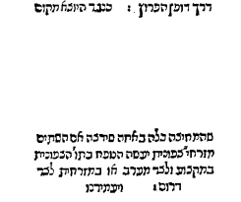
People often wonder what those who studied these editions were supposed to do with the blank space (especially if it was preceded by the word “Kazeh”). Some conjecture that they were supposed to have the diagram(s) drawn in for them. Here is an example of such a case involving the 1580 Basel edition available through Google books
https://books.google.co.il/books?id=AbhSAAAAcAAJ&pg=PP13#v=onepage&q&f=false

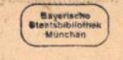
Basel 1580
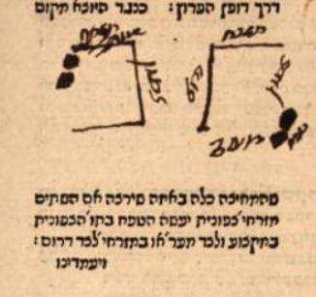

The diagrams eventually were included in later editions.
Here is Frankfurt/Oder 1698
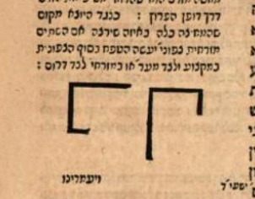

As usual, it is patterned after Chochmat Shlomo (Cracow 1582). In this case, Chochmat Shlomo gave two sets of diagrams to choose from, one with Mizrach, Tzafon and Darom, and one without. The Frankfurt/Oder edition chose the easier way and that pattern continued through the Vilna Shas of 1882.
