“ שנתות היו בהין”
An Unusually Artistic Picture in “Rashi”
מנחות פז:
Eli Genauer

מתני׳ - שבע מדות של לח היו במקדש, הין ,וחצי הין, ושלישית ההין, ורביעית ההין, לוג, וחצי לוג, ורביעית לוג.
There were seven measuring vessels for liquids in the Temple. There was a vessel of one hin, (i.e., twelve log.) Three vessels were used to measure the oil and wine for the meal offerings and libations that accompanied the sacrifice of an animal. For a bull there was a vessel of one-half of a hin, (i.e., six log;)and for a ram there was one of one-third of a hin,( i.e., four log;) and for a lamb there was one of one-quarter of a hin, (i.e., three log.) In addition, there was a vessel that held one log to measure the oil for all standard meal offerings; and another one that held one-half of a log for measuring the water used in the rite of a Sotah and also for the oil used in the loaves accompanying the thanks offering (see 88a); and another one that held one-quarter of a log for measuring the water used in the purification of a Metzorah and also for the oil used in the wafers and loaves that the Nazir brings on the day that his term of Nazirut ends.
ר' אליעזר בר ר' צדוק אומר שנתות היו בהין, עד כאן לפר, ועד כאן לאיל, עד כאן לכבש
Rabbi Eliezer, son of Rabbi Tzadok, says: It was not necessary to have several vessels of different sizes; rather, there were graduations [שנתות] on the vessel that held one hin indicating that until here is the quantity needed for the bull, and until here is the quantity needed for the ram, and until here is the quantity needed for the lamb.
On the statement of Rabbi Eliezer bar Tzadok, Rashi comments,
לא היה שם ז ‘מדות אלא הין בלבד, ושנתות, סימנין היו בו, עד כאן לפר כו' והכי נמי היו בו שנתות ללוג וחצי לוג
There weren’t seven different vessels in the Beit HaMikdash, rather there was just one vessel which could hold one hin. This hin sized vessel had markings on the side of it indicating until here for a bull…and also there were markings for one log and one half of a log….

The Tuzurat HaDaf of the Vilna Shas ( Vilna 1885) on this section looks like this. As you can see, Rashi’s comment is accompanied by an uncharacteristically artistic picture.
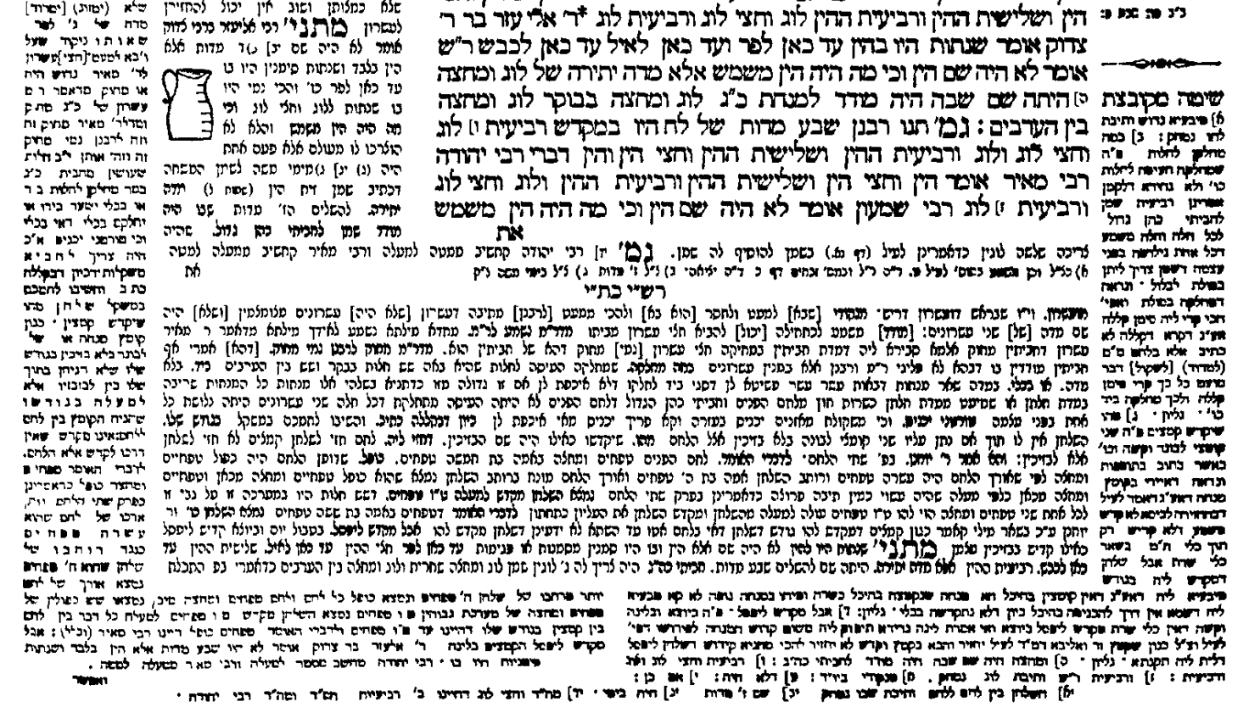
Here is a close-up of the picture
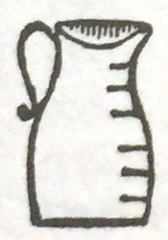
As noted in footnote 2 below, there is a strong likelihood that this comment and accompanying picture cannot be attributed to Rashi, but rather to some other Rishon. This is supported in another way by a manuscript ( known as Vatican ebr.487) we have on Menachot which seems to be the source for the “Rashi Ktiv Yad” in the Vilna Shas identified by Rav Betzalel Ashkenazi as in fact belonging to Rashi. The text of the Vilna Shas in the Rashi Ktiv Yad on this section is exactly the same as this manuscript.
( starting with “Shenatot Hayu BaHin..Lo Haytah Sham” on the second line)
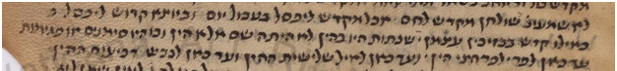
As you can see, there is no picture in this manuscript.
The first printed edition of Menachot was by Bomberg ( Venice 1522) and the source of the commentary which was placed in the “Rashi location” was most likely a manuscript. The Bomberg editions did not include diagrams but oftentimes left an empty space when there was one in the manuscript which served as their source. We do not find such an empty space here, leaving us with the supposition that there was no picture in the manuscript that Bomberg used.
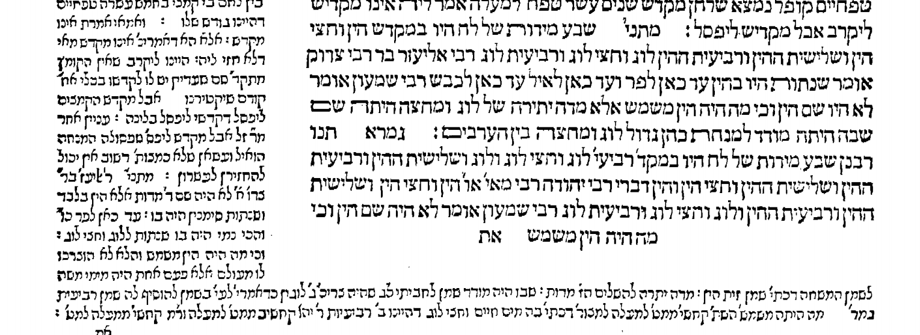
We sometimes find “missing diagrams” in the Chochmat Shlomo by Rav Shlomo Luria ( Prague 1582) and Chochmat Manoach by Rav Monoach Hendel ben Shemaryah ( Prague 1612 ) but these two commentaries were not written on Menachot.

We do however find a picture in the book “Omek Halacha” by Rabbi Jacob Koppelman ( Cracow 1593) . It quotes the word סימנין as being in Peirush Rashi and then says "כזה" followed by a rudimentary diagram of a vessel with markings
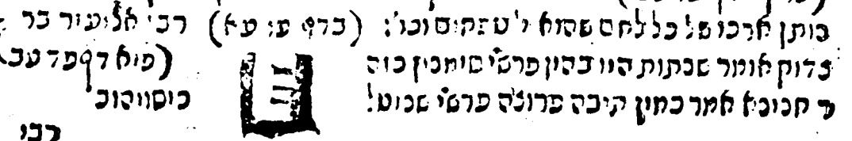

Omek Halacha was published again in Amsterdam 1710, this time with a picture of the markings which is a bit more clear.
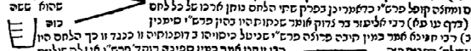
As mentioned before, we do not find this picture in the Bomberg edition on Menachot of 1522 nor in any subsequent printed editions of the Talmud for the next approximately 200 years. The first edition of Masechet Menachot to include a picture was one printed in Frankfurt am Main in 1720, just 10 years after the Omek Halacha Amsterdam edition of 1710.
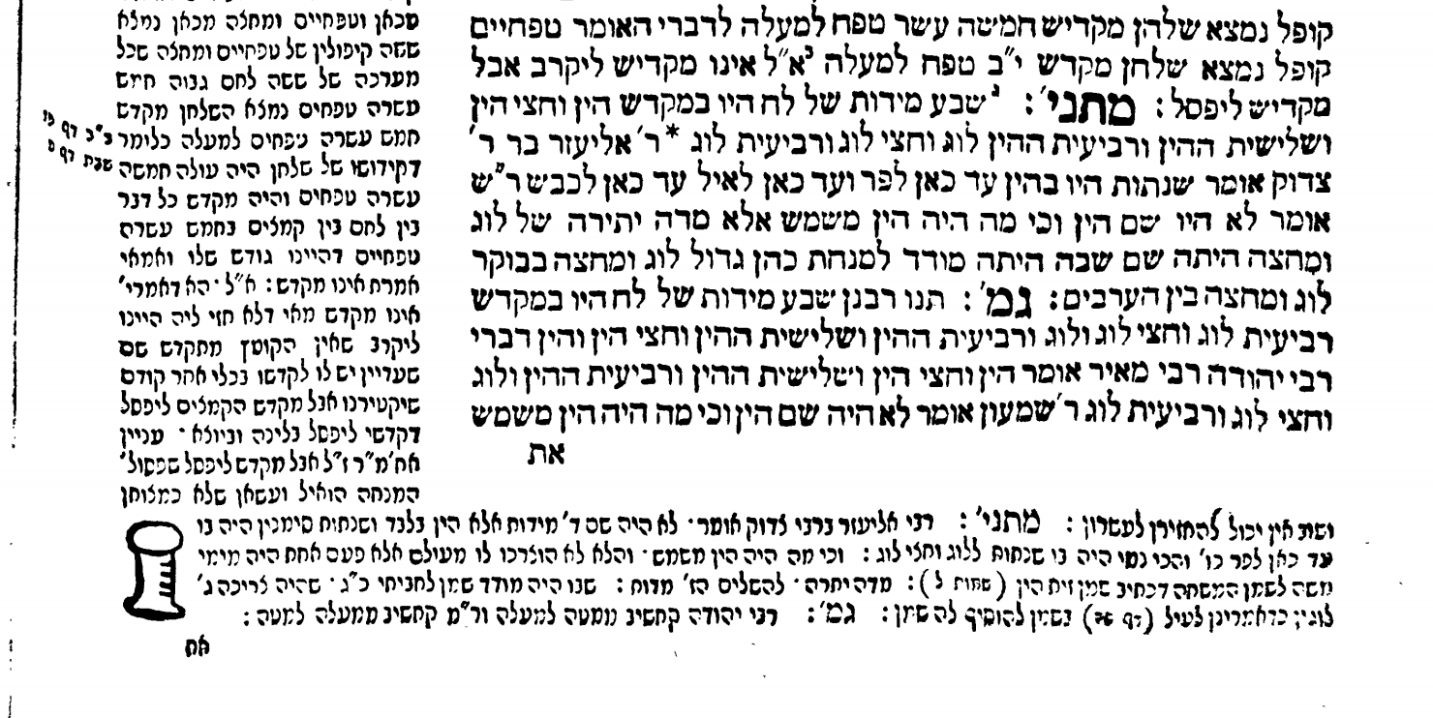
I believe this was the impetus for the editors of the Frankfurt am Main edition to include a picture basing it on the scholarship of Rabbi Jacob Koppleman. We do not know whether Rav Jacob Koppleman’s source was a manuscript or just an attempt to illustrate the words of what he called “Rashi”.
Finally, what has happened to the picture over the years is a good example of what I term “diagram evolution”.
It started out looking like this
In an edition printed in Zhitomir in 1860, it evolved into this
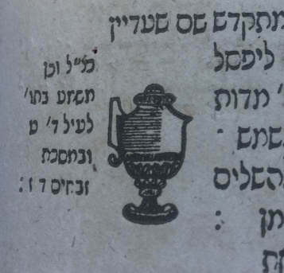

Text, translation and commentary courtesy of Sefaria.org (The William Davidson digital edition of the Koren Noé Talmud, with commentary by Rabbi Adin Even-Israel Steinsaltz )
There is discussion on whether what is shown in the space normally reserved for Rashi in our editions of Menachot was actually written by Rashi. Rav Natan Nata Rabbinowicz ( author of Dikdukei Sofrim) writes that our “Rashi” was written by a student of Rabbeinu Gershom. ( Dikdukei Sofrim on Menachot 86a note 6 where he writes ...מפני שהפרוש הזה המיוחס לרש״י הוא כנראה מתלמיד הרבינו גרשום מאור הגולה והעתיק ברובו לשון הרבינו גרשום מאור הגולה) Rav Betzalel Ashkenazi (the author of the Shita Mekubetzet) writes that for chapters 7-10, the “Rashi” in the standard editions was not written by Rashi and he substitutes his own version which is indicated by the words “Rashi Ktiv Yad” in the Vilna Shas. The editors of the Vilna Shas record this opinion at the beginning of the 7th chapter ( Menachot 72a) as follows: וזה לשונו "זה הפּרוש אשר הוא בדפוס מפרק אלו המנחות עד שתי הלחם אינו מפי׳ רש״י ז״ל והוא של פרשן אחר, וזה לשון רש״י כּ״י". Since this Mishneh is between chapters 7-10, it is Rav Ashkenazi’s opinion that the comment containing the picture of the jug was not written by Rashi, but rather by a פרשן אחר. Rabbi Raphael Halprin seems to agree that this picture does not belong to a comment of Rashi. See רש"י חייו ופירושיו, חלק בּ'-הלפרין, רפאל בן יעקב-הוצאת "הקדש רוח יעקב”-תשנ"ז where he lists all the diagrams contained in Rashi’s commentary to Talmud Bavli, including many in Menachot, and leaves out this one ( page 499)

