Restoring the Text of Maharam Lublin
Eli Genauer
Bava Basra 13a- Maharam Lublin (Meier Einei Chachamim) on Tosfot “חד גיסא נגרא וחד גיסא נהרא “
The Gemara discusses a case of a square field which is to be divided equally between two brothers. On one side of the field there is an irrigation channel, and on the other side, there is a river. A river is considered to be superior to a channel because it’s source of water can be guaranteed. How do you divide this field so that each brother gets similar access to the river and to the channel?
Tosfot quotes Rabbeinu Chananel who explains the case and the Halacha.” פירש רבינו חננאל”
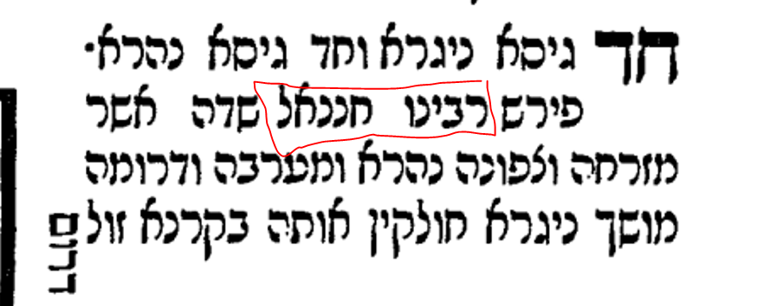
Maharam Lublin (1558-1616) in his Sefer Meier Einei Chachamim explains why Tosfot, according to Rabbeinu Chananel, differs with Rashi on the details and the pursuant Halacha in this case.
Meier Einai Chachamim, first edition, Venice 1619
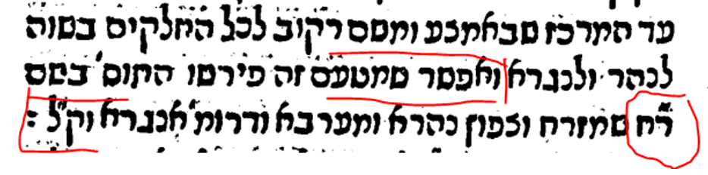“It is possible because of this reason that Tosfot explains in the name of ר״ח ( רבינו חננאל) that the river is on the eastern and southern side ( of the field) and the channel is on the western and southern side”
The next edition of Meier Einei Chachamim recorded it the same way
Frankurt am Main 1709 – The Roshai Taivot are ר״ח ( רבינו חננאל)
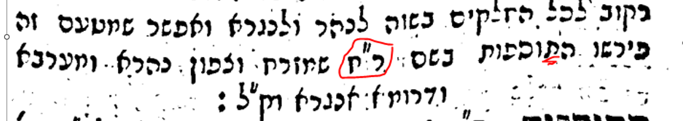
This followed in the editions of Sulzbach 1787 and Polonia 1809
Meier Einei Chachamim was included under the name Maharam Lublin in the back of the Vilna Shas (in the same section as Maharsha and Chochmat Shlomo). Somehow by then, the Roshai Taivot had been changed to ר״ת indicating that Tosfot interpreted this section according to רבינו תם. It is easy to see how this could happen as a “ת” looks very much like a “ח”. But is still incorrect.
Vilna Shas 1882
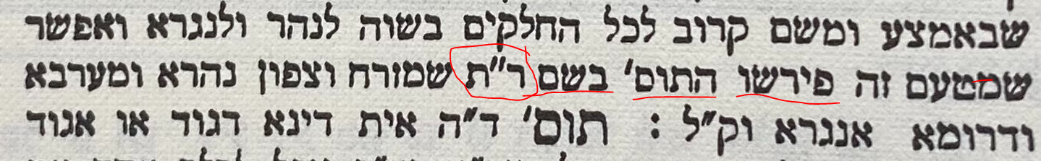
For many years, “new” editions of the Talmud were just photo-offsets of the Vilna Shas. This mistake was therefore enshrined in the time period of the 1880’s until very recently. But recently, new editions of the Shas have appeared and one of their hallmarks is that the words have been re-typeset. This gave the editors an opportunity to correct some of the obvious errors that crept into the Vilna Shas.
Two of the new editions did not notice this error and continued printing it as it appeared in the Vilna Shas.
Shas #1
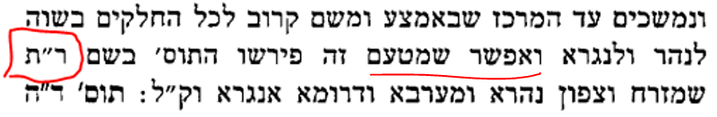
Shas #2
But one new edition, that of Oz VeHadar (2006), did notice this error and fixed it so that it reflected the original words of Mahram Lublin
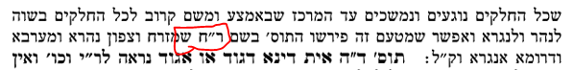
It is a very minor error, but fixing it shows the care that should go into any new edition of Shas.

