Gemara Eiruvin 5a - אם יש שם פס ד׳ -An Erroneous Diagram in Vilna Shas
(Thank you to Aharon for his assistance with this article)
Summary- The illustration which appears in the classic Vilna Shas for the Rashi “ אם יש שם פס ד׳” is incorrect for two reasons. There is ample evidence that a diagram was drawn by Rashi preceded by the word “Kazeh”. Over time, it was represented in different ways. The illustration as it appeared in manuscripts and in many earlier printed editions reflected more accurately the words of Rashi. What is most curious is that an earlier edition of Eruvin by the Romm publishing house (1859) was also more accurate than that of the iconic Romm Vilna Shas. (1881)
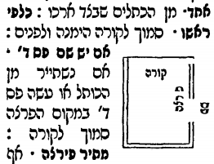
Gemara Eiruvin 5a
The Gemara discusses a case where the Korah is less than ten Tefachim from the ground…how do you fix it? The Gemara says you have to dig down until the height from the area you dig up to the Korah is 10 Tefachim. The ditch you dig extends the width of the alleyway but the question is how long does that ditch have to extend into the Mavuy? Rav Yosef says the length of the ditch only has to be four Tefachim and Abaye says four Amos. The Gemara then wants to say that Rav Yosef holds like Rav Ami who says that a distance inwards of four Tefachim is considered Chashuv enough to maintain the status of a Mavuy which is made Mutar by a Korah. The case of Rav Ami is the basis for the illustration in Rashi.
This is the Lashon of the Gemara:
היה פחות מעשרה טפחים וחקק בו להשלימו לעשרה, כמה חוקק? כמה חוקק?!! כמה דצריך ליה! אלא משכו בכמה? רב יוסף אמר בארבעה, אביי אמר בארבע אמות.
The Gemara considers a new case: If the Korah spanning the entrance to an Mavoy was less than ten Tefachim above the ground, and one hollowed out the ground under the cross beam in order to complete the distance from the ground to the Korah to ten, how much must he hollow out? The Gemara is surprised by the question: How much must he hollow out? Whatever is necessary for it to increase the height to at least ten Tefachim! Rather, the question is as follows: How far must the hollowed-out area extend into the Mavoy in order to render it permitted to carry throughout the Mavoy? Rav Yosef said: Four (Tefachim). Abaye said: Four Amos.
רש״י
משכו - של חקק לתוך אורך המבוי- בדבר הבולט כגון מיעוט שייך למימר רוחב, ובדבר השוקע ומקיפות אותו מחיצות כגון חקק, שייך לומר לשון משך:
רב יוסף - דבעי לעיל טפח, הכא בעי ארבעה- דהתם דאיתיה לדופן ולמעוטי קאתי, בהיכר בעלמא סגי, הכא דהשתא הוא דמשוי ליה דופן, בין לרב יוסף ובין לאביי בעינן דליתחזי האי דופן לשיעור הכשר אורך מבוי שלם, הלכך לרב יוסף שיעור משך מבוי בדּ’ טפחים, ואביי סבירא ליה שיעור משך מבוי בדּ’ אמות:
The Gemara continues:
לימא בדרבי אמי ורבי אסי קמיפלגי, דאיתמר, מבוי שנפרץ מצידו כלפי ראשו, איתמר משמיה דרבי אמי ורבי אסי, אם יש שם פס ארבעה מתיר בפירצה עד עשר, ואם לאו, פחות משלשה מתיר, שלשה אינו מתיר, לרב יוסף אית ליה דרבי אמי, לאביי לית ליה דרבי אמי.
The Gemara suggests: Let us say that these Amora’im disagree with regard to the ruling of Rav Ami and Rav Asi. As it was stated with regard to the following question: If the side wall of a Mavoy was breached toward its entrance, i.e., close to where the alleyway opens into the public domain, what is the Halakha? It was stated in the name of Rav Ami and Rav Asi: If an upright board (Pas) four Tefachim wide remains of the original wall or is set up where the original wall had ended, the Korah or side post at the entrance to the Mavoy renders it permitted to carry in the Mavoy even if there is a breach of up to ten Amos wide. And if there is no upright board (Pas) there, the following distinction applies: If the breach is less than three Tefachim, the Korah or side post renders it permitted to carry in the Mavoy, based on the principle of Lavud. If the breach is three or more Tefachim, the Korah or side post does not render it permitted to carry. The Gemara proposes that Rav Yosef, who says that the hollowed-out area need only extend four Tefachim, adopts the opinion of Rav Ami, whereas Abaye, who requires a hollowed-out area of four Amos, does not adopt the opinion of Rav Ami
רש״י
שנפרץ מצידו אחד - מן הכתלים שבצד ארכו:
כלפי ראשו - סמוך לקורה הימנה ולפנים:
אם יש שם פס ד׳ - אם נשתייר מן הכותל או עשה פס ד׳ במקום הפרצה סמוך לקורה:
: 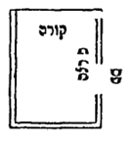
This is the diagram in the Vilna Shas
The picture illustrates the above comments of Rashi. There is a Mavoy that is breached towards its top, (Klapei Rosho) and there is a Korah which extends the width of the alleyway on the very top. There is a “Pas” (or the remnant of the wall) towards the top right which is four Tefachim into the “Pirtzah” next to the “Korah”. Problem: The Pas here is situated in the wrong place , not next to the “Pirtzah”. Also, there is too much space between the Korah and the Pas. See picture below ( Peirush Chai) which shows the Pas joined together with the Korah at a right angle.
מתיר פירצה - אף על גב שנשתייר שם עדיין פירצה עד עשר, דכיון דיש הכשר אורך מבוי מן הקורה עד הפירצה, לא בטל ליה תורת פתח מקמאי, ובמלתיה קאי, וקורתו מתירתו, ופירצתה מתרת, כיון דלאו יותר מעשר תורת פתח עליה, ומבוי אינו נפסל בפתחים הרבה, אי נמי שבקו בני מבוי פתחא קמא ונפקו ועיילי בההיא פירצה משום דדרך קצרה היא להם, אפ"ה לא בטלה תורת פתח וקורה מן הראשון, משום דהוי פתח לדּ’ הסמוכין לו הואיל וד׳ אורך ראויין לקורה דיש בהן הכשר מבוי:
ואם לאו - דאין שם פס ד׳:
פחות מג׳ - אם הפירצה פחותה מג׳:
מתיר - תיקון המבוי את המבוי, שהרי כלבוד דמי, ואין כאן פירצה, ואם הפירצה ג׳ אינו מתיר, דכיון דממעטין בני מבוי בהילוכן ומקצרין את דרכן דרך אותה פירצה, חיישינן דילמא שבקי פתחא רבה ועיילי ונפקי בההיא פירצה, ובטיל ליה פתחא קמא ובטלה קורה דידיה, ואין קורה למבוי זה, והאי טעמא מפרש לקמן בפירקין:

This is the case of Rav Ami of the broken wall. (Peirush Chai)
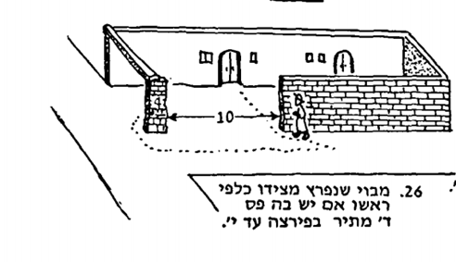
The wall portion that says “4” is either a “Pas” (upright board) or what remains of the original wall. It is attached to the “Rosh”. This diagram and all the other modern diagrams such as in Artscroll (commentary section) and the Oz Vehadar edition all have the remaining wall area (or the Pas) situated under the Korah. There is no space between the Korah and the side wall. The key in the Rashi is where it says דכיון דיש הכשר אורך מבוי מן הקורה עד הפירצה . This indicates that there is no gap.
Piryo B’Ito also shows the Pas extending to being underneath the Korah “MiTachas L’Korah”
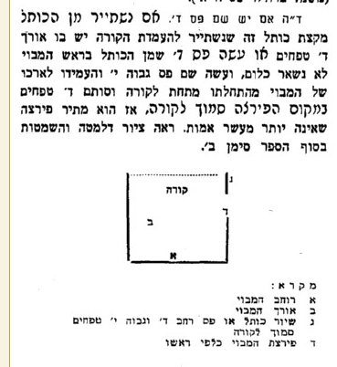
The history of the Vilna Shas Diagram
Pesaro - c.1511 – The Korah is on top of the diagram, and the wall is breached somewhere “Klapei Rosho” meaning that a part of the wall (or a new Pas) which is attached to the Korah remains. The word Pas is included in the diagram because it comes after the Rashi which speaks about a Pas of four Tefachim being there. There is no need to identify the Pirtzah as it is obvious that it is the “break”. This diagram is the same as in two manuscripts. The diagram appears in the same place as in the Vilna Shas.
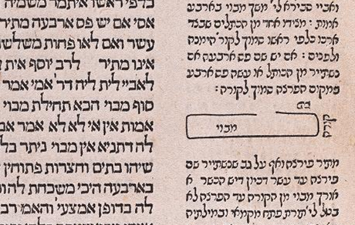
Bomberg 1521 mirrors the location of the diagram in the Pesaro edition below, right below “Im Yaish Sham Pas Daled”
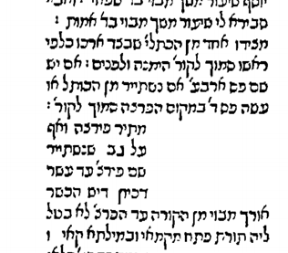
Amsterdam 1714 –The Pas is clearly marked, is in the correct location. The Pirtzah is indicated and also placed correctly. As expected, there is a space between the pas and the Korah just as in the Chochmas Shlomo, which is the source for the Amsterdam diagram.

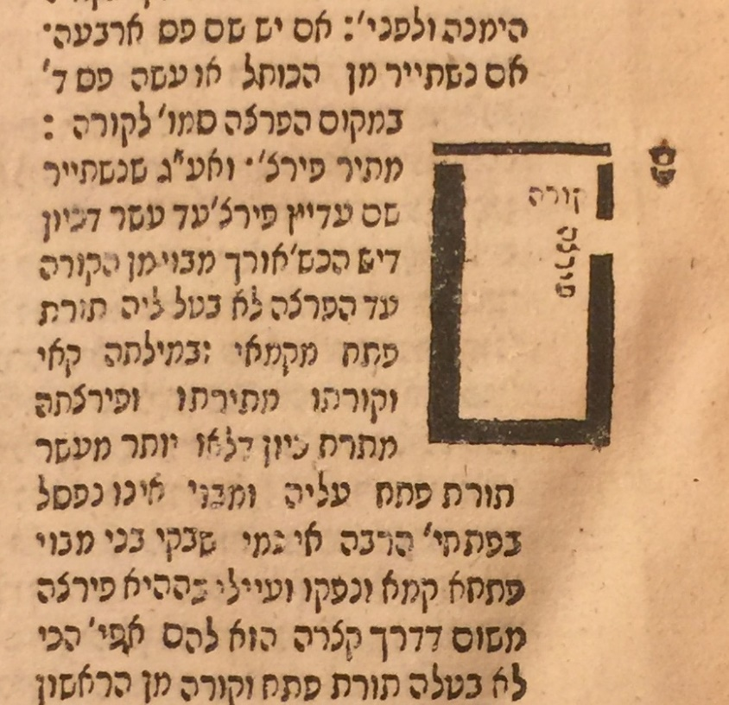
Slavuta 1808 – It is better than Vilna Shas on the placement of the partial wall on top which should be attached to the Korah, but it is incorrect on where the Pas is.
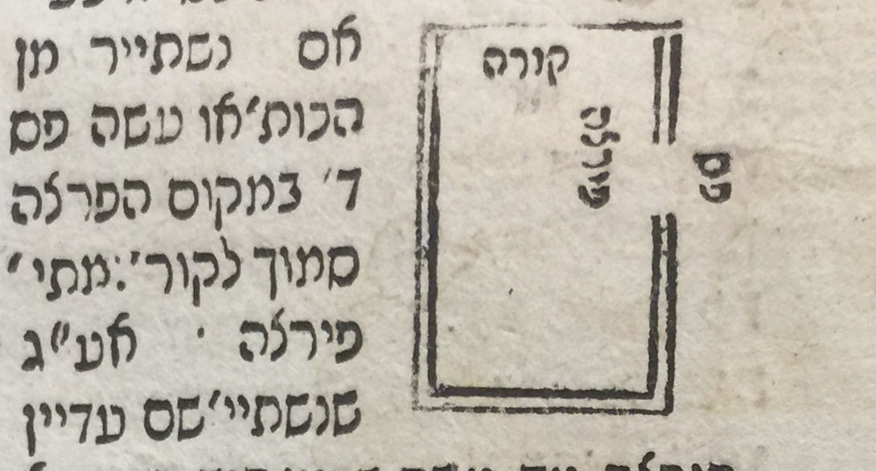
Vilna Romm 1859 – More correct than Vilna Shas 1881 – 1. The Pas is not in the wrong place and 2. no space between the top partial wall and the Korah. The question remains, why did the Vilna Shas change it for the worse?
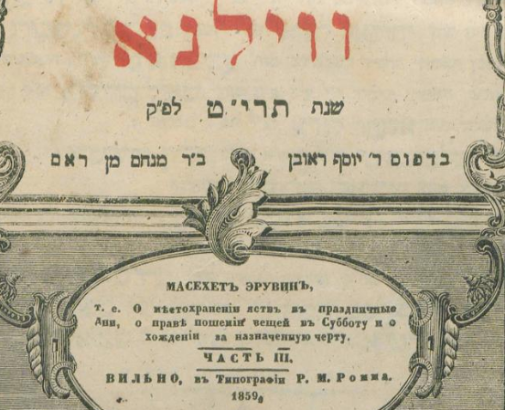
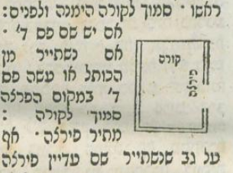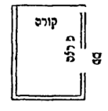
Vilna 1859 Vilna Shas
Manuscripts – I checked seven manuscripts of Rashi on Eruvin. All had a diagram preceded by the word “Kazeh”. Below are a few examples.
The earliest manuscript is Munich 216 ( from the 1200’s)
We see the Pirtzah and a piece attached to the “top” although nothing is identified with words. The word “Kazeh” follows the Rashi with the Dibbur HaMaschil of “Klapei Rosho.” This seems to be the “mother” of the illustration as it looks similar in Paris 324 and even in Pesaro 1511
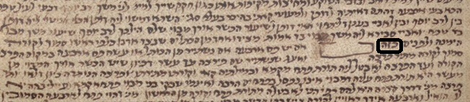
The National Library of France, Paris, France Ms. hebr. 324– 13th-14th century
http://aleph.nli.org.il:80/F/?func=direct&doc_number=000129229&local_base=NNL01

Similar in design and orientation to Munich 216 with the additional designation that is a Mavuy and which way is lengthwise. The word Kazeh follows the Rashi with the Dibbur HaMaschil of Klapei Rosho.
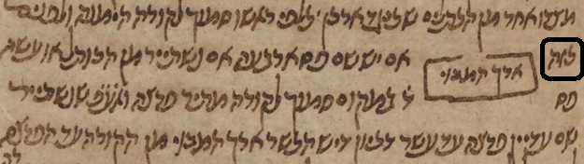
Russian state library. The Pas intersects with the Korah and the proportions are good.
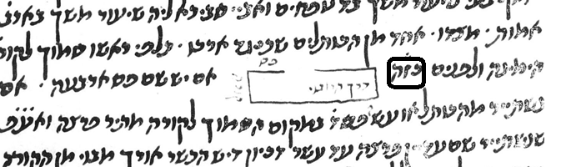
Oz Vehadar Friedman – This is correct. This edition went out of its way to make the Korah be on top of the Pas (or portion of the wall that remained) Also, the drawing itself indicates that the Pas and the Korah are of different materials.

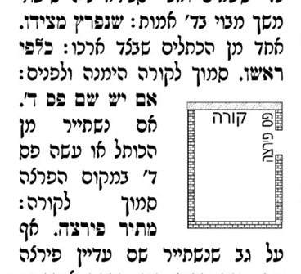

Conclusion: A diagram was drawn by Rashi who included the word “Kazeh”. Over time, it was represented in different ways. The diagram in the Vilna Shas is incorrect in two obvious ways.

